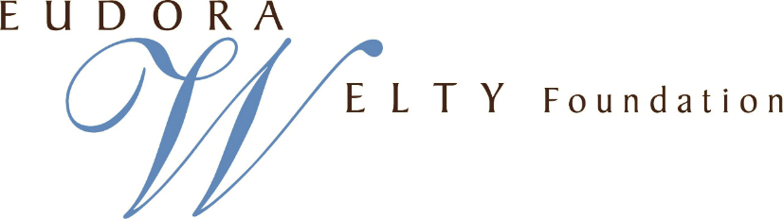

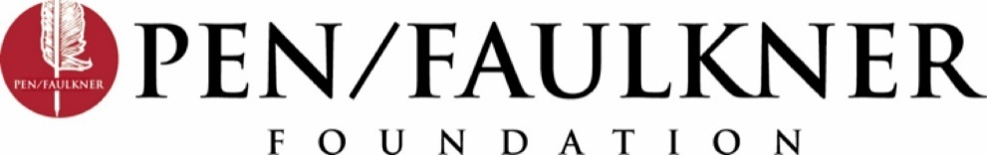

For Immediate Release Media Contact:
February 16, 2016 Emma Snyder: esnyder@penfaulkner.org or 202-898-9063

Salman Rushdie to Give the Inaugural
Eudora Welty Lecture in Washington, D.C.

A new endowed lecture to be presented by the PEN/Faulkner Foundation and the Eudora Welty Foundation

(WASHINGTON, DC) – The PEN/Faulkner Foundation and the Eudora Welty Foundation announce the creation of the Eudora Welty Lecture to be held in Washington, D.C. as part of the PEN/Faulkner Reading Series. The first Eudora Welty Lecture will be held on October 20, 2016, at the National Cathedral. The inaugural lecturer will be Salman Rushdie.

The Eudora Welty Lecture will be open to the public and will be an important and unique addition to Washington, D.C.’s literary culture. The lecturers will be chosen from the most prominent writers working in the English language today. Each lecturer will present an original talk on the topic of their creative origins. Lecturers will receive a $20,000 honorarium.

In the words of Richard McCann, President of the PEN/Faulkner Foundation: “Here we have the startling opportunity to hear Salman Rushdie, born in Mumbai, half a world away from Welty’s Jackson, Mississippi, exploring the experience, as Welty did in her collected lectures, One Writer’s Beginnings, of what it means to become an artist.”

Eudora Welty is the author of such acclaimed works as The Optimist’s Daughter, Delta Wedding and the short story collection A Curtain of Green. Her many honors include the Pulitzer Prize, the American Book Award for Fiction, and the Gold Medal for the Novel, given by the American Academy and Institute of Arts and Letters for her complete works in fiction.

The Eudora Welty Lecture is inspired by the lectures Welty delivered at Harvard University in 1983 as part of the William E. Massey Sr. series. Over three lectures (Listening, Learning to See, and Finding a Voice), Welty surveyed her life as a writer and detailed the inextricable bonds between her upbringing in Jackson, Mississippi and her remarkable literary voice.

Speaking at Harvard, she said, “The events in our lives happen in a sequence in time, but in their significance to ourselves they find their own order, a timetable not necessarily—perhaps not possibly—chronological. The time as we know it subjectively is often the chronology that stories and novels follow: it is the continuous thread of revelation.”

Following in the tradition of Eudora Welty, Salman Rushdie will deliver the inaugural Eudora Welty Lecture on October 20, 2016, leading us along his own thread of revelation.

Holmes Adams, Chairman of the Eudora Welty Foundation, adds, “Eudora Welty and Salman Rushdie center their stories in vastly different cultures and places, but their works share common universal themes. The Welty Foundation is extremely pleased that Mr. Rushdie is the inaugural lecturer for the Welty Lecture. He begins a tradition of great writers who follow in the steps of Eudora Welty in discussing their creative origins.”

Salman Rushdie is the author of twelve novels, including the Man Booker Prize-winning Midnight’s Children, The Satanic Verses, The Moor’s Last Sigh, and, most recently, Two Years Eight Months and Twenty-Eight Nights. He has also published a significant body of non-fiction, including The Jaguar Smile, Imaginary Homelands, and The Wizard of Oz. In 2008, Midnight’s Children was named the best novel to have won the Booker Prize in its first 40 years of existence. He has won the European Union’s Aristeion Prize for Literature and is a fellow of the Royal Society for Literature and a Commandeur des Arts et des Lettres. In June 2007, Queen Elizabeth II awarded him a knighthood.
The publication of Rushdie’s The Satanic Verses in 1988 sparked immediate controversy in the Islamic world for its depiction of the Prophet Muhammad. The book was banned in many countries and, famously, burned in a public demonstration in Bradford, England. Iran broke diplomatic relations with the United Kingdom over its publication and placed threats on the author’s life, forcing Rushdie into hiding for years.
In a 1965 essay, “Must the Novelist Crusade,” Welty addressed politics’ role in fiction: “Great fiction, we very much fear, abounds in what makes for confusion; it generates it, being on a scale which copies life, which it confronts. It is very seldom neat, is given to sprawling and escaping from bounds, is capable of contradicting itself, and is not impervious to humor. There is absolutely everything in great fiction but a clear answer. Humanity itself seems to matter more to the novelist than what humanity thinks it can prove.”
The inaugural Eudora Welty Lecture will be held at the Washington National Cathedral on October 20, 2016. A D.C. landmark that is both a place for spiritual enrichment and an architectural feat, the National Cathedral welcomes all religious traditions and sects, and all people. A fundamental component of the Cathedral’s mission is to act as a public convener, bringing people together in conversation and partnership. This makes it the ideal venue in which to honor Welty’s written and humanistic legacy, and to celebrate every writer’s most cherished freedom: the freedom of speech.
------------------------------------------------------------------------------------------------------------------------
The PEN/Faulkner Foundation, now celebrating its 36th year, is committed to building audiences for literature and bringing writers together with their readers. This mission is accomplished through readings at the Folger Shakespeare Library by distinguished writers who have won the respect of readers and writers alike; the PEN/Faulkner Award for Fiction, the largest peer-juried award for fiction in the United States; the PEN/Malamud Award, honoring excellence in the short story; and the Writers in Schools program, which brings nationally and internationally-acclaimed authors to public and public charter high school classrooms in Washington, D.C. and Baltimore, MD to discuss their work with students.
The Eudora Welty Foundation was established in 1999 to support and further the appreciation of Welty’s life, work, and literary legacy, assist the Mississippi Department of Archives and History with the preservation of the Welty home and garden in Jackson, Mississippi, and encourage reading and writers. The Welty Foundation partners with Millsaps College to support a Eudora Welty Scholar; develops teaching resources that will expand appreciation of Welty’s writing and photography; supports study of her work; and hosts seminars, competitions, and festivals for young writers, established authors, and the public. The Welty Foundation’s programming emphasizes Welty’s striking intellect and creative powers, her devotion to the humanities, the place of literature in our lives, and the role of the writer in our society.
The Washington National Cathedral serves as a spiritual resource for our nation and as a house of prayer for all people. First established in 1907, the National Cathedral strives to be an indispensable ministry for people of all faiths and perspectives and a sacred place for the United States of America in times of celebration, crisis, and sorrow.
The Cathedral is dedicated to service in four ways: 1) as a national church, dedicated to serving the country and its many faith traditions; 2) as a national treasure, dedicated to serving visitors and pilgrims; 3) as the Cathedral of the Episcopal Diocese of Washington, dedicated to serving the diocese, the three schools on the Cathedral Close, and its worshiping community; and 4) as a convener, dedicated to create programming to bring people together in conversation and partnership. In 2007, the Cathedral marked the start of its second century with a centennial celebration including festivals, reunions, exalted liturgy, concerts, lectures, and the inauguration of the new dean’s Sunday Forum.
For more information, visit http://eudorawelty.org and http://www.penfaulkner.org

